Asimov, The Last Man on Earth, Fawcett Crest Books, Aug 1982, No DJ Fine softcover with all 352 pages intact with no marks. ISBN 0449245314
Clifford D. Simak foresees a time when dogs and robots inherit the earth – and only one man is left to combat them.
ID 000280 Price $15 Box 4
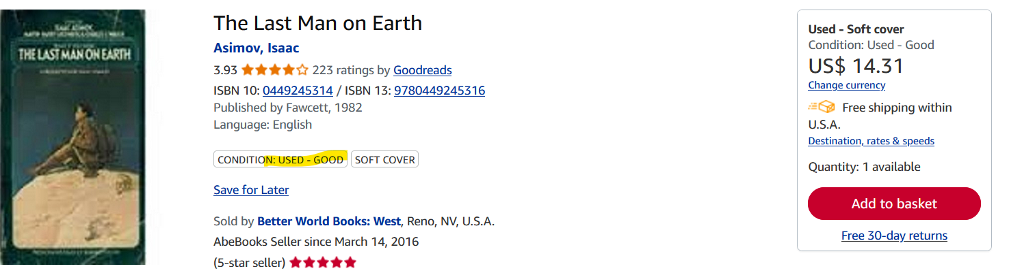
ABE books

